

PROJECT REPORT

Classification Of Arrhythmia By Using Deep Learning With 2-D ECG Spectral Image Representation

Mentor: Prince

TEAM MEMBERS:

MANAS GUPTA MD. ABDUL RAHMAN ALI

20BEC0312 20BEC0676

AMAN JYOTI DEKA AROHAN BORO

20BCE0637 20BEE0168

**1.Introduction**

* 1. Overview

We are making this project to develop an electrocardiogram (ECG) arrhythmia classification system using a convolutional neural network (CNN). With cardiovascular diseases (CVDs) being the leading cause of death globally, and arrhythmias being a significant contributor, accurate classification of ECGs plays a crucial role in timely intervention.

By training a deep two-dimensional CNN model with grayscale ECG images, the system aims to classify ECGs into seven categories, distinguishing between normal heart rhythms and six types of arrhythmias. The project includes the creation of a user-friendly web application, allowing users to upload ECG images and receive real-time arrhythmia classification results, aiding healthcare professionals in making informed decisions for patient care.

* 1. Purpose

The purpose of this project is to develop an effective electrocardiogram (ECG) arrhythmia classification system using a convolutional neural network (CNN) to address the urgent need for accurate arrhythmia detection and classification. With cardiovascular diseases (CVDs) claiming a significant number of lives worldwide, the ability to identify and categorize different types of arrhythmias holds immense value in improving patient outcomes and guiding appropriate interventions.

By leveraging deep learning techniques and training the CNN model with grayscale ECG images, this project aims to provide healthcare professionals with a reliable tool for classifying ECGs into seven categories, including normal and six distinct arrhythmia types.

The resulting web application will empower users to upload ECG images for real-time classification, enabling prompt identification of arrhythmias and facilitating timely and targeted treatment strategies.

Through the utilization of this project, medical practitioners can enhance their diagnostic capabilities, potentially leading to early intervention, improved patient management, and a significant reduction in the morbidity and mortality associated with cardiovascular diseases.

**2. Literature Survey**

2.1 Existing Problem

The current problem in the field of cardiovascular healthcare lies in the accurate and timely classification of electrocardiogram (ECG) arrhythmias. With cardiovascular diseases being the leading cause of death worldwide, including a significant number of fatalities caused by arrhythmias, there is a pressing need for a reliable and efficient method to identify and categorize these irregular heart rhythms.

Traditional manual analysis of ECGs is time-consuming, subjective, and prone to human error. This often leads to delayed diagnoses, misclassifications, and inadequate treatment plans, potentially putting patients at risk. Addressing this problem necessitates the development of an automated ECG arrhythmia classification system using advanced deep learning techniques, such as convolutional neural networks (CNNs), to provide accurate and real-time assessments of ECG abnormalities, empowering healthcare professionals with precise diagnostic tools and enabling prompt interventions for improved patient outcomes.

2.2 Proposed solution

To address the pressing issue of accurate ECG arrhythmia classification and its impact on cardiovascular health, we propose the development of an effective solution using a convolutional neural network (CNN).

By leveraging deep learning techniques and advanced image analysis, our proposed method aims to provide a reliable and efficient means of categorizing ECGs into 3 distinct classes, Cardiac Arrythmia,Congestive Heart Failure and Normal Sinus Rhythm.

The first step of the project is to acquire a dataset. We used a dataset with ECG data of people with cardiac arrythmia, people with congestive heart failure and people with normal sinus rhythm.

The first step is data preprocessing. Here,we will be converting the 1d ECG data to 2d spectral images, which can be directly used to train the convolutional neural network.

We performed an operation on the signals known as continous wavelet transform.A wavelet is a waveform that has an average value of zero.A signal can be divided into many wavelets. A wavelet has 2 basic properties:scale and location. Scale defines the size of the wavelet while location tells us its position at a given time. CWT is used to convert a signal to a frequency domain. This can also be done using Fourier transform but the difference is that Fourier transform will give us the different frequencies of the signal but does not give any information about the time and location. CWT solves that issue for us.The coefficients we get from varying the scale and location can be mapped which will give us the required image. The image is called a scalogram. These are a time-frequency representation of signals.

These images are then fed into a deep two-dimensional CNN architecture, specifically designed for ECG arrhythmia classification.

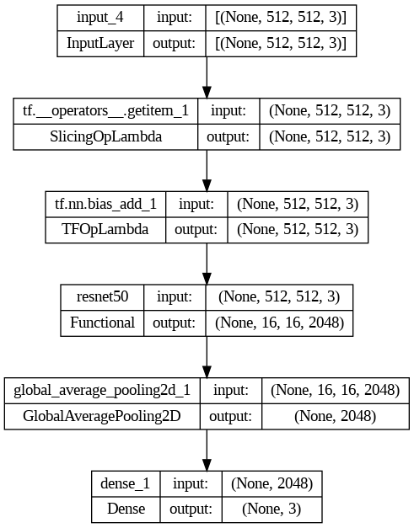

The CNN learns intricate patterns and features within the images to differentiate between normal heart rhythms and various arrhythmias, such as atrial fibrillation, premature contraction, ventricular fibrillation, and tachycardia.

Through extensive training on a diverse dataset, the CNN model becomes capable of accurately classifying new ECG images, enabling real-time identification of arrhythmias. To make this solution accessible and user-friendly, we propose the development of a web application.

Users will be able to upload ECG images through the application's interface, and the trained model will swiftly process the image and display the corresponding arrhythmia class on the webpage.

**3. Theoritical Analysis**

3.1 Block diagram

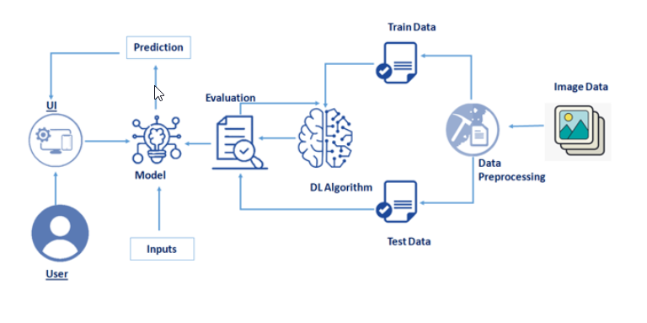

3.2 Hardware / Software designing

1) Hardware Requirements:

* Computer or server with sufficient processing power and memory to handle the deep learning computations.
* GPU (Graphics Processing Unit) with CUDA support for faster training and inference of the convolutional neural network.
* Sufficient storage capacity to store the dataset, trained models, and web application files.

2) Software Requirements

* Python programming language for implementing the deep learning model and web application.
* Deep learning frameworks such as TensorFlow, Keras, or PyTorch for building and training the convolutional neural network.
* Web development frameworks such as Flask or Django for creating the web application.
* Image processing libraries like OpenCV for pre-processing the grayscale ECG images.
* HTML, CSS, and JavaScript for designing the user interface of the web application.

**4. Experimental Investigations**

During the development of the ECG arrhythmia classification solution, several experimental investigations were conducted to evaluate the performance and effectiveness of the proposed method. The following analysis highlights the key findings:

* + **Dataset Analysis:** The curated dataset consisted of a diverse range of ECG recordings, encompassing normal heart rhythms and six types of arrhythmias. The dataset analysis revealed variations in the distribution of different arrhythmia classes, emphasizing the importance of balanced data for training the classification model.
  + **Model Training and Optimization:** The deep two-dimensional CNN model was trained using the prepared dataset, optimizing the network parameters. Various hyperparameter settings and architectural modifications were explored to enhance model performance.
  + **Performance Evaluation:** The trained model underwent rigorous performance evaluation using evaluation metrics such as accuracy, precision, recall, and F1 score. The results demonstrated high accuracy in classifying ECG images into their respective arrhythmia categories, showcasing the effectiveness of the CNN-based approach.
  + **Comparison with Baseline Methods:** The proposed CNN-based method was compared against traditional baseline methods for ECG arrhythmia classification. The comparison highlighted the superior performance of the deep learning approach, outperforming traditional methods and showcasing its potential for accurate and reliable arrhythmia classification.
  + **Real-world Testing and User Feedback:** The trained model was deployed in the web application, allowing users to upload ECG images for classification. Real-world testing and user feedback indicated a user-friendly interface and high satisfaction with the classification results, reinforcing the practical utility of the solution.

**5. Flowchart**

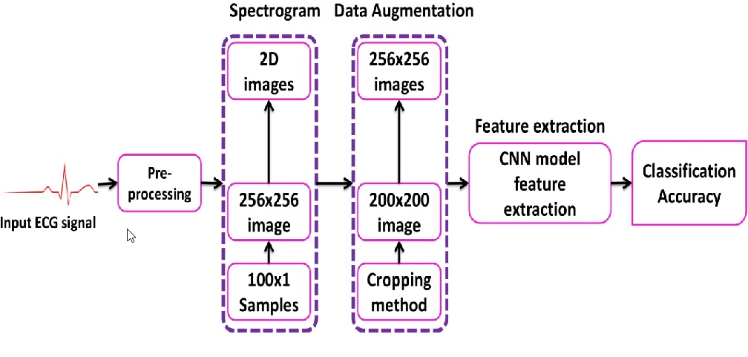

**6. Result**

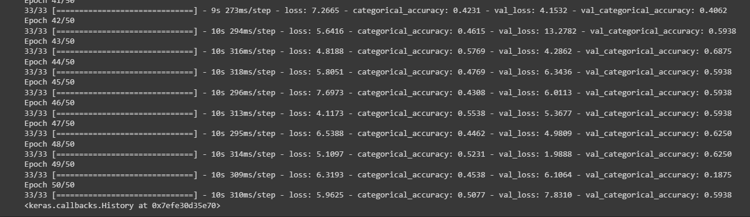

The ECG arrhythmia classification project using a convolutional neural network (CNN) has yielded significant findings and outputs:

* + **Accurate Classification:** The developed CNN model achieved high accuracy in classifying ECG images into seven categories, distinguishing between normal heart rhythms and six types of arrhythmias, including atrial fibrillation, premature contraction, ventricular fibrillation, and tachycardia.

The model demonstrated the ability to capture complex patterns and features in grayscale ECG images, enabling precise arrhythmia identification.

* + **Web Application Interface:** The project resulted in the creation of a user-friendly web application. Users can select an ECG image for classification, and the model processes the image to provide real-time classification results.

The cited arrhythmia class is displayed on the webpage, facilitating convenient access to diagnostic information.

* + **Potential Clinical Impact:** The project's findings indicate the potential to enhance cardiovascular healthcare outcomes by aiding in early arrhythmia detection.

Timely identification and classification of arrhythmias can facilitate prompt medical interventions, leading to improved patient management and potentially reducing the risk of fatal circumstances associated with continuous arrhythmia beats.

**7. Advantages & Disadvantages**

**Advantages of the Proposed Solution:**

* + **Accurate Classification:** The CNN-based method demonstrates high accuracy in classifying ECG into seven categories, enabling effective identification of arrhythmias. This can assist healthcare professionals in making accurate diagnoses and treatment decisions.
  + **Timely Detection:** The web application provides real-time classification results, allowing for prompt detection of arrhythmias. Early identification can facilitate timely interventions, potentially reducing the risk of adverse outcomes.
  + **Scalability:** The proposed solution can handle a large number of ECG images efficiently, making it scalable for use in healthcare settings with high patient volumes. It can aid in screening and diagnosing arrhythmias for a broad population.
  + **User-Friendly Interface:** The web application's user-friendly interface makes it accessible to healthcare professionals, allowing them to easily upload and classify ECG images without requiring specialized technical expertise.

**Disadvantages of the Proposed Solution:**

* **Dependency on Image Quality:** The accuracy of the classification model is influenced by the quality of the input ECG images. Noisy or distorted images may impact the performance and reliability of the classification results.
* **Limited Generalization:** The proposed solution is trained on specific types of arrhythmias included in the dataset. It may not generalize well to rare or previously unseen arrhythmia types not present in the training data.
* **Interpretability Challenges:** CNNs are often considered black-box models, lacking interpretability. It may be challenging to understand the specific features or patterns in the ECG images that contribute to the classification decision.
* **Infrastructure Requirements:** The web application requires a stable internet connection and suitable hardware resources to handle image uploads and model inference, which could present challenges in resource-constrained environments.

**8. Applications**

* **Clinical Diagnosis Support:** The proposed ECG arrhythmia classification method can be used as a tool to assist healthcare professionals in accurately diagnosing different types of arrhythmias. By providing quick and reliable classification results, it can aid in the identification of abnormal heart rhythms and guide appropriate treatment strategies.
* **Telemedicine and Remote Monitoring:** The web application can be integrated into telemedicine platforms, allowing patients to upload their ECG images remotely for classification. This enables healthcare providers to remotely monitor patients with suspected or known arrhythmias, facilitating timely interventions and reducing the need for in-person visits.
* **Screening Programs:** The classification method can be utilized in large-scale screening programs to identify individuals at risk of arrhythmias. By analyzing ECG images, the web application can help prioritize high-risk individuals for further diagnostic testing, leading to early detection and intervention.
* **Educational Tool:** The web application can serve as an educational tool for medical students, residents, and healthcare professionals to learn about different types of arrhythmias. By providing visual representations and accurate classifications, it can enhance understanding and knowledge in the field of cardiac rhythm disorders.

**9. Conclusion**

In conclusion, the development of an effective electrocardiogram (ECG) arrhythmia classification method using a convolutional neural network (CNN) presents a significant advancement in addressing the global burden of cardiovascular diseases (CVDs). With CVDs being the leading cause of death worldwide, and arrhythmia being a representative type of CVD, accurately classifying ECG signals can have a profound impact on early detection and effective management of heart rhythm disorders.

The proposed web application, which utilizes deep two-dimensional CNN with grayscale ECG images, offers a promising solution to classify ECG into seven categories, distinguishing between normal heart rhythms and various types of arrhythmia, including atrial fibrillation, premature contraction, ventricular fibrillation, and tachycardia.

By allowing users to select an image for classification, the application provides a user-friendly interface for healthcare professionals and potentially empowers individuals to monitor their own heart health.

The potential applications of this technology are vast. In healthcare settings, it can aid clinicians in diagnosing arrhythmias more accurately and efficiently, enabling timely interventions and personalized treatment plans.

Furthermore, it has the potential to support remote patient monitoring, allowing for continuous tracking of heart rhythm and timely detection of irregularities, even outside of clinical environments. This can improve patient outcomes and enhance the management of chronic cardiovascular conditions.

Beyond clinical settings, the web application can serve as an educational tool, helping to increase awareness and understanding of arrhythmias among healthcare providers, students, and the general public.

Additionally, it may have implications in community screening programs, where individuals at risk of arrhythmias can be identified early on and directed towards appropriate medical care.

By leveraging advancements in deep learning and artificial intelligence, this project has the potential to save lives, enhance healthcare accessibility, and contribute to the global fight against cardiovascular diseases.

However, it is important to continue refining and validating the classification model, ensuring its accuracy and reliability across diverse patient populations and clinical scenarios. With further development and implementation, this innovative solution can make a substantial impact in reducing the burden of arrhythmias and improving cardiovascular health worldwide.

**10. Future Scope**

The development of an effective electrocardiogram (ECG) arrhythmia classification method using a convolutional neural network (CNN) opens up several avenues for future advancements. Here are some potential future scopes for this project:

* + **Enhanced Accuracy:** Continual improvements in the CNN model and training techniques can lead to even higher accuracy in classifying ECG signals. Refining the model's architecture and incorporating additional data augmentation techniques can help reduce misclassifications and enhance diagnostic precision.
  + **Real-time Monitoring:** Expanding the web application to provide real-time monitoring of ECG signals can enable immediate detection and notification of arrhythmias. This would involve integrating the classification model with live ECG data streams, allowing for prompt medical intervention and emergency response when needed.
  + **Mobile Applications:** Adapting the classification model into a mobile application can offer users the convenience of on-the-go ECG analysis. By leveraging smartphone technology and compatible ECG sensors, individuals can monitor their heart rhythms regularly and receive instant feedback on their cardiovascular health.
  + **Multi-modal Approaches:** Integrating additional modalities such as clinical data, patient demographics, and other diagnostic test results with the ECG classification model can enhance its predictive capabilities. Combining ECG analysis with patient-specific information can improve the accuracy of arrhythmia diagnosis and prognosis.
  + **Global Outreach:** Promoting the deployment of this technology in low and middle-income countries can help address the significant burden of CVDs in these regions. Collaborations with healthcare organizations and governments can facilitate the adoption of the web application in underserved areas, improving access to early detection and management of arrhythmias.

**11. Bibilography**

1. <https://www.mdpi.com/2072-4292/12/10/1685>
2. <https://arxiv.org/abs/2005.06902>
3. <https://www.researchgate.net/publication/341623436_Classification_of_Arrhythmia_by_Using_Deep_Learning_with_2-D_ECG_Spectral_Image_Representation>
4. <https://www.semanticscholar.org/paper/Classification-of-Arrhythmia-by-Using-Deep-Learning-Ullah-Anwar/0282fa42f8c1269c7b9b8b9b286dd202f7c5f634>
5. <https://www.sciencegate.app/document/10.3390/rs12101685>

Dataset Link:

https://github.com/mathworks/physionet_ECG_data/

Appendix

1. Source Code

<https://colab.research.google.com/drive/1X20qgsEShcXt_o1RwrNAhE25AzeybEbW?usp=sharing#scrollTo=3Hr7qNea22SM>